ISE 360: Intro to Robotics
HW6: Getting Started with Robot Operating System 2 (ROS 2)

- Abstract
In this lab, you will implement different concepts in ROS to control the motion of a TurtleBot (as shown in Figure 1).
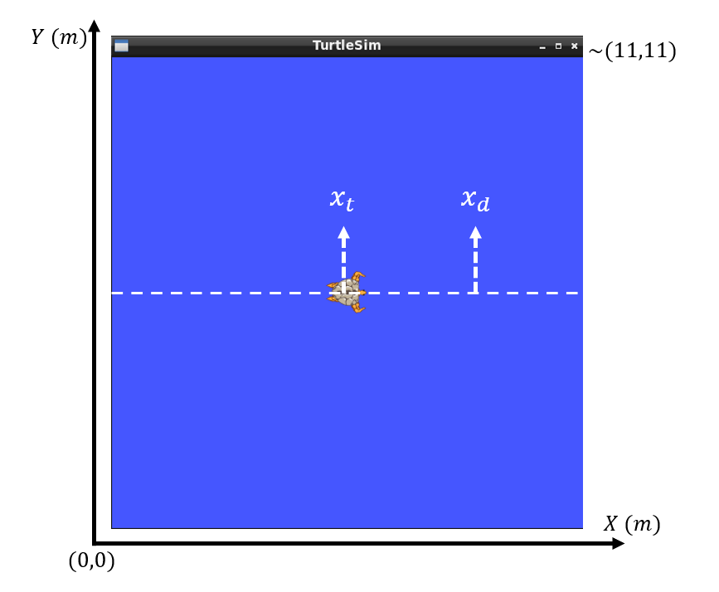
Figure 1. Controlling the motion of TurtleBot from an initial $x_{t}$ to a target/desired position $x_{d}$ on the X axis.
You will review and utilize different tools such as
- Docker
- Linux OS
- GitHub
- ROS 2 (creating packages, nodes, messages, publishers, and subscribers)
to achieve this goal.
2. Methods
2.1. Required Components
To complete this lab, you need to follow these steps.
- Create a ROS 2 package named “robotics_lab1”. The package must have the following dependencies
  - rclcpp
  - geometry_msgs
  - std_msgs
  - turtlesim
- Create a new message named “Turtlecontrol”. This message must include two components
  - a control gain “kp” (you can use float32)
  - a desired position “xd” (you can use float32)
- Write one control node that includes two subscribers and one publisher, such that
  - It subscribes to the correct topic and receives position information from the turtlesim_node.
  - It creates a new topic and subscribes to it to receive the desired position and a control gain (see the descriptions of the Proportional controller) using the message created in step 2. You must use the following name for the new topic
    - /turtle1/control_params
  - It implements a proportional control and publishes to the velocity command topic of the turtlesim node. You can set the control loop frequency to 10 Hz (similar to the examples solved in class).
- Test your control code by publishing for example kp = 1 and xd = 8 via the new topic and message. You can use rqt_gui to easily publish messages in the new topic and test your code. You should see the simulated robot moving toward the target position and eventually stopping there.
2.2. Proportional Control
Proportional control is one of the simplest and at the same time most effective methods for autonomous control. Full technical descriptions were covered earlier in this course and ISE 333. This controller generates a control input (here the velocity of the Turtlebot based on the block diagram shown in Figure 2) to minimize an error between the desired output (here a target position for the Turtlebot) and the current output (here the current position of the TurtleBot).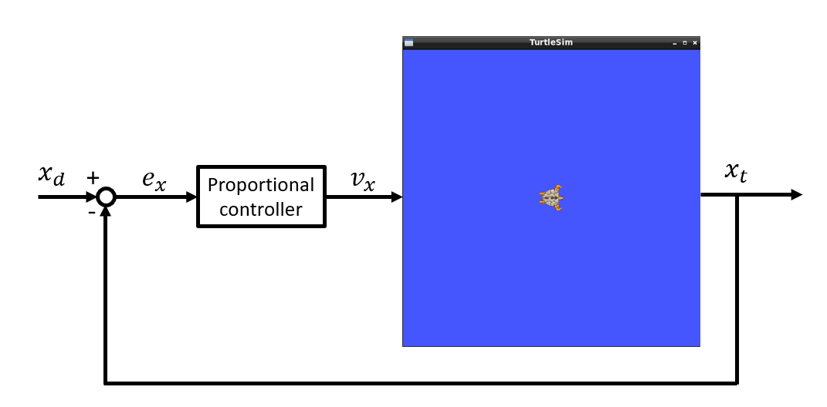
Figure 2. Block diagram of the proportional control algorithm for controlling the 1D motion of TurtleBot.
The Proportional controller equation for this example is
$$v_{t}= K_{p}(x_{d}- x_{t})$$
where
$v_{x}$: is the Turtlebot velocity command (here only a single DoF motion along $X$ axis),
$x_{d}$: is the desired position of the Turtlebot along the $X$ axis,
$x_{t}$: is the current position of the Turtlebot along the $X$ axis,
$e_{x}= x_{d}- x_{t}$: is the current position error of the Turtlebot along the $X$ axis,
and $K_{p}$: is the control gain.
According to this control algorithm, the control velocity input to the robot is larger whenever the error is larger and vice versa. This controller produces zero velocity commands when the robot reaches its desired location as the error $e_{x}$ reaches zero. Increasing/decreasing the control gain $K_{p}$ results in faster/slower motions of the robot towards the target position.

    - Grading Criteria
Your submissions will be graded according to the following distributions.
- Proper comments on the codes (10 pts)
- Package structure and file organization (10 pts)
- Successful implementation of the control node
  - Subscribers (20 pts each, remember that you need two of them)
  - Proportional controller (10 pts)
  - Publisher for sending commands to TurtleBot (20 pts)
- Providing the solutions in a GitHub repository (10 pts)

